Cyber security analyst internship program

Week 2 Assignment
Name | Talha Ghulab
Department | Red Team( Cyber security )
Institute | It Simplera
Date | 12:07:2026
Instructor | Talal Rehman
Supervisor | Seniour Cyber Security Analyst

iNTRODUCTION:
Computer networking is one of the fundamental components of modern information technology and cybersecurity. It enables devices to communicate, share resources, and exchange data efficiently across local and global networks. A strong understanding of networking concepts is essential for identifying, analyzing, and resolving network-related issues.
This report has been prepared as part of my Cyber Security Internship to demonstrate practical knowledge of basic networking concepts and essential Windows networking commands. The tasks included in this report focus on examining network configuration using the ipconfig /all command and understanding the functionality of commonly used networking commands for troubleshooting and network administration.
Completing these tasks has enhanced my practical skills in network diagnostics, configuration analysis, and command-line utilities, which are essential for a career in cybersecurity and network administration.
Task1:network information(ipconfig/all)

This task is to identify the system's IPv4 Address, MAC Address, and Default Gateway using networking commands in Kali Linux. These details are essential for understanding how a computer communicates within a network and accesses external resources.
1. Display IPv4 Address and MAC Address:

IPv4 Address
The IPv4 address is a unique logical address assigned to a device on a network. It allows the device to communicate with other devices using the Internet Protocol (IPv4). Every device connected to a network must have an IP address.

MAC Address
The Media Access Control (MAC) address is a unique physical address assigned to a network interface card (NIC) by the manufacturer. It is used for communication within the local area network (LAN) and helps identify devices at the data link layer.
Command :
IP a
Screenshort :
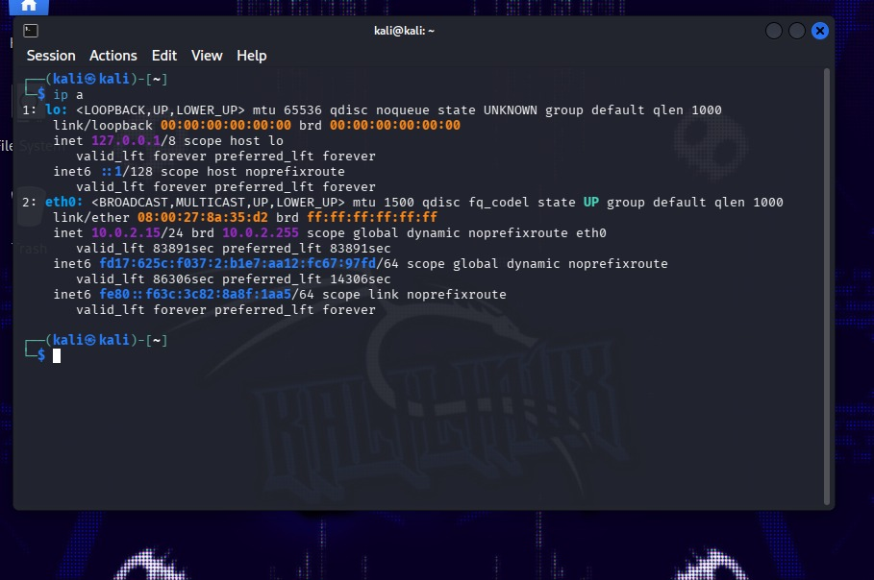

IPv4 Address:

10.0.2.15
MAC Address
08:00:27:11:a1:bf

2.Display Default gateway:

MAC Address
The Media Access Control (MAC) address is a unique physical address assigned to a network interface card (NIC) by the manufacturer. It is used for communication within the local area network (LAN) and helps identify devices at the data link layer.
Command :
IP route
Screenshort :
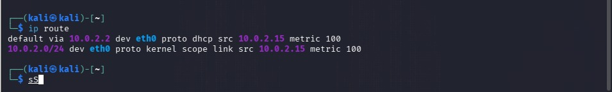
Default Gateway:
default via 10.0.2.2 dev eth0
Task 2 : basic network Commands
This task is to understand and practice basic networking commands in Kali Linux. These commands are used to examine network configuration, test connectivity, trace network paths, perform DNS lookups, and view the ARP table for troubleshooting and network administration.
1.Network configuration
Command: (Ip a)

Purpose
Displays detailed information about the network interfaces, including the IPv4 address, IPv6 address, MAC address, and interface status.
2.test Internet Connectivity
Command: (ping -c 4 google.com)
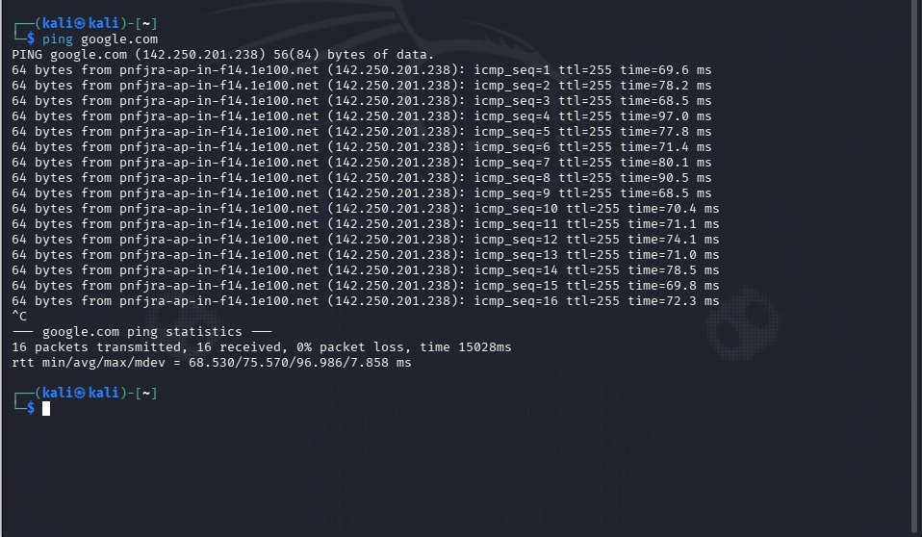

Purpose
Tests network connectivity by sending four ICMP Echo Request packets to google.com and measures the response time and packet loss.
3.trace the route
Command: (traceroute google.com)
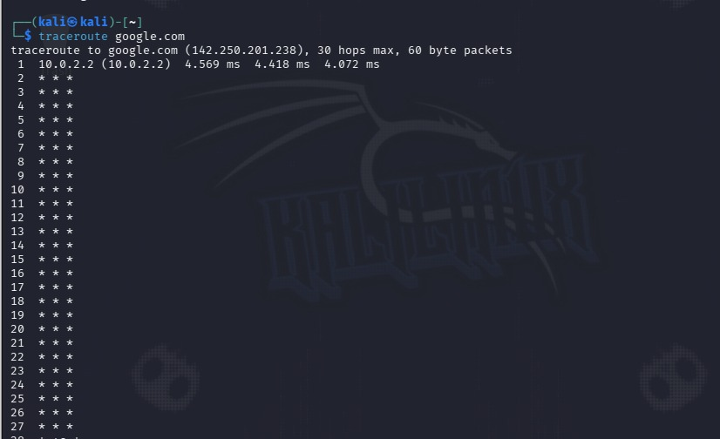

Purpose
Displays the path (hops) that network packets take from the local computer to the destination server.
- Dns lookup
Command: (nslookup google.com)
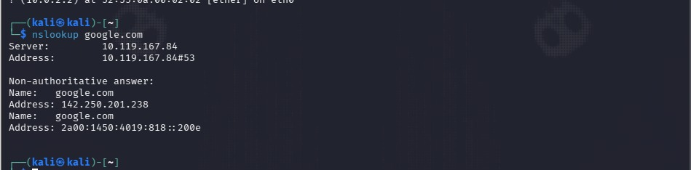

Purpose
Queries the DNS server to translate the domain name google.com into its corresponding IP address.
- Display arp
Command: (arp -a)
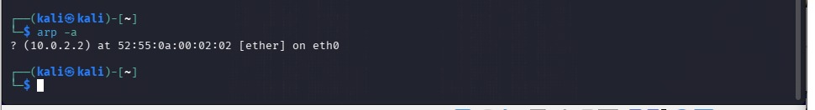

Purpose
Displays the ARP (Address Resolution Protocol) table, showing the mapping between IP addresses and MAC addresses of neighboring devices on the local network.

Task 3 : Router vs switch

Feature | Router | Switch
Primary Function | Connects different networks and routes data between them. | Connects devices within the same Local Area Network (LAN).
OSI Layer | Layer 3 (Network Layer) | Layer 2 (Data Link Layer) (Some managed switches also support Layer 3 features.)
Addressing Used | Uses IP Addresses to forward packets. | Uses MAC Addresses to forward frames.
Network Connection | Connects different networks (e.g., LAN to Internet). | Connects multiple devices within the same network.
Broadcast Domain | Separates broadcast domains, reducing unnecessary traffic. | By default, all ports are in the same broadcast domain unless VLANs are configured.
Collision Domain | Each interface is a separate collision domain. | Each switch port is a separate collision domain.
Speed | Generally slower because it processes IP routing decisions. | Faster for local communication since it switches frames based on MAC addresses.
Security Features | Supports Firewall, NAT, Access Control Lists (ACLs), and VPNs. | Supports VLANs, Port Security, and MAC Address Filtering.
Common Use Cases | Internet access, connecting branch offices, and inter-network communication. | Office LANs, schools, data centers, and connecting computers, printers, and servers.
Example Device | Home Wi-Fi Router, Cisco ISR Router, MikroTik Router | Cisco Catalyst Switch, TP-Link Switch, Netgear Switch

Task 4 : Ipv4 vs ipv6

Feature | IPv4 | IPv6
Address Length | 32-bit address | 128-bit address
Address Format | Four decimal numbers separated by dots | Eight groups of hexadecimal numbers separated by colons
Example Address | 192.168.1.10 | 2001:0db8:85a3:0000:0000:8a2e:0370:7334
Total Address Space | Approximately 4.3 billion addresses | Approximately 340 undecillion addresses (3.4 × 10³⁸)
Address Configuration | Manual configuration or DHCP | Stateless Address Auto-Configuration (SLAAC) or DHCPv6
Security | IPsec is optional | IPsec support is built into the protocol specification
Header Size | Variable (20–60 bytes) | Fixed (40 bytes), making processing more efficient
Broadcast Support | Supports broadcast communication | Does not support broadcast; uses multicast and anycast instead
Network Address Translation (NAT) | Commonly required due to limited addresses | Generally not required because of the vast address space
Performance | Less efficient routing and larger routing tables | More efficient routing with simplified packet headers

Task 5 : Osi model
Layer (Top to Bottom) | Primary Function | Common Protocol | Networking Device
7. Application Layer | Provides network services directly to end-user applications. | HTTP, HTTPS, FTP, SMTP, DNS | Proxy Server / Gateway
6. Presentation Layer | Translates, encrypts, and compresses data before transmission. | SSL/TLS, JPEG, MPEG | Gateway
5. Session Layer | Establishes, manages, and terminates communication sessions between devices. | NetBIOS, RPC, PPTP | Gateway
4. Transport Layer | Ensures reliable data delivery, flow control, and error recovery. | TCP, UDP | Firewall / Load Balancer
3. Network Layer | Determines the best path for data and performs logical addressing (IP). | IP, ICMP, OSPF | Router
2. Data Link Layer | Transfers data between devices on the same network using MAC addresses. | Ethernet (IEEE 802.3), PPP, ARP | Switch / Bridge
1. Physical Layer | Transmits raw bits over physical media such as cables or wireless signals. | Ethernet (Physical Standard), DSL, USB | Hub / Repeater / Network Cable

